[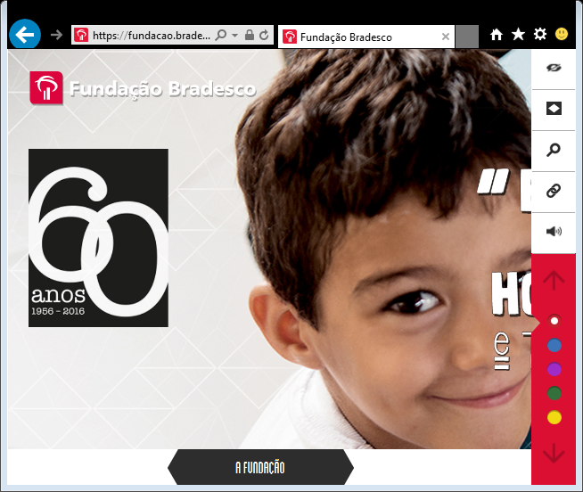](https://fundacao.bradesco/)